Homework EECS6017

Marwedel:

Chapter1:

7) How do different hardware technologies differ with respect to their energy efficiency?

ASICs have the largest number of operation per joules, followed by FPGA which are one order of a magnitude less and the programmable processors have the lowest number of operation per Joules. The efficiency order is in this way: ASIC, FPGA, DSP. MPU, Cell and RISC.

if we want to aim at very power- and energy-efficient designs,

we should use ASICs instead of flexible designs based on processors or

re-programmable logic.

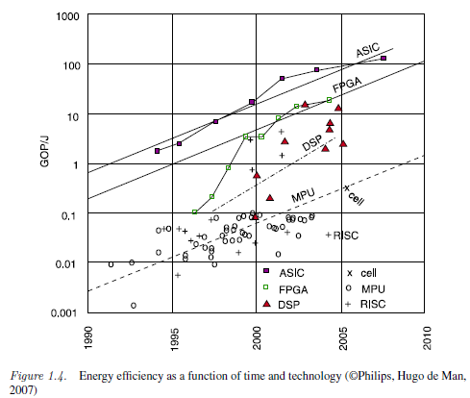

8) Suppose that your mobile uses a lithium battery rated at 720 mAh. The nominal voltage of the battery is 3.7 V. Assuming a constant power consumption of 1 W, how long would it take to empty the battery? All secondary effects such as decreasing voltages should be ignored in this calculation.

V=3.7 V and I/h = 720 mAh P=1W find the time to empty the battery. P=VI , I = P/V

10) Which real-time constraints are called “hard real-time constraints”?

Hard real-time constraints are constraints that will result in a catastrophe if not met.

11) How could you define the term “reactive system”?

A reactive system is a system in continual interaction with it’s environment and waiting for an input from that one in order to perfom an action or give an output.

Chapter3:

BRIEFLY explain the meaning of figure 3.15 (1-2 short sentences)

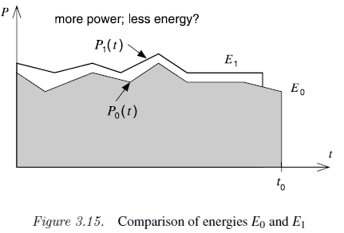

The figure 3.15 show that sometimes reducing the execution time will not reduce the energy consumption. So it’s not correct to assume that always reducing the execution time in a system we design will cause a reduction in the energy consumption.

6.Why might it be reasonable to use scratch pad memory in an embedded system but not cache memory?

Using scratch pad memories reduces the energy per access given that no checking will need to be done in hardware since frequently used variables and instructions will be allocated to the address space.

7.Do problem 8 in Marwedel, chapter 3.

check with group..



8. why is 2’s c integer arithmetic more “efficient” than sign-magnitude integer arithmetic?

With 2’s complement integers we can represent more negative numbers and we don’t get to 0’s which can be a problem when it comes to hardware implementation.

9-22. Do the exercises on fixed point and floating point numbers in lecture 6.

4. What is the binary representation of the following two decimal numbers in U(8, 8)? In U(4, 4)?

a. 12.25 = 1 1 0 0.01

b. 16.125 = 1 0 0 0 0.001

5. What is the smallest nonzero number we can represent with the U(7, 8) format? In A(7,8)?

6. What is the largest number we can represent with the U(7, 8) format? In A (7,8)?

7. Accuracy is the magnitude of the maximum diﬀerence between a real value and its representation.

The resolution is the smallest non-zero magnitude representable.

What is the accuracy of an U(7,8) number format? What is its resolution? What is the smallest

number one can represent in such a format? What is the largest number?

8. Give the representations for  a. -1 in A(7,8); b. -1 in A(3,4)

9. What is 0 in A(7,8)?

10. Suppose your system is measuring two quantities, X, and Y. The magnitude of X is <= 100, and it can be measured to an accuracy of 10-2. X can be positive or negative. Y is positive, and its magnitude is <= 10. Y can also measured to an accuracy of 10-2. Your system computes X*Y. What fixed point representation A(m,n) should you use for input? For output?

11. Show how to code as a binary [floating point] number: a. -1.0; b. 0.5; c. 1.5; d. -1.5

12. What floating point number is represented by **1** | **1000 0010** | **111 1000 0000 0000 0000 0000**

13. Why do we need and how do we represent +oo, -oo, and NaN?

14. What is a denormalized number?

15. What number is represented by 0 | 00000000 | 00100000000000000000000

16. What is “overflow” for floating point numbers? Give an example.

17. What is “underflow” for floating point numbers? Give an example.

23. Why do we need to create a test bench file for simulating an Altera design?